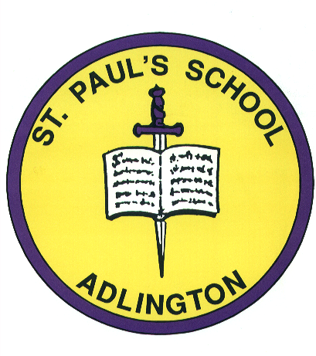
Adlington St. Paul’s
Church of England Primary

Railway Road, Adlington, Chorley, Lancashire, PR6 9QZ Tel: 01257 480276

Head teacher: Mrs J. Burger
Deputy Head: Mr R. Findlow



E-mail: bursar@adlingtonstpauls.lancs.sch.uk www.adlingtonstpauls.lancs.sch.uk
‘Whatever you do, work at it with all your heart’. Colossians 3 v 23

Friday 2nd February 2024
Dear Parents/Carers,
The children have been invited to take part in a writing competition called ‘What’s Your Story Chorley?’ which has been organised by Chorley Council. The theme this year is ‘Read All About It’ and the children have been set the challenge of creating a newspaper article about an event that has happened in Chorley.
Local children’s author Susan Brownrigg visited school last Friday to explain that the theme for the competition has come from the character Gracie Fairshaw from her series of books. This week in school, the children have completed a video workshop led by Susan Brownrigg to create some ideas to include in their pieces of writing.
The children in Years 2 and 6 will create their pieces of writing in school and the children in Years 3, 4, and 5 can choose to complete the challenge at home if they wish. The competition closes on Tuesday 20th of February but we are asking for all competition entries to be brought into school by Monday 12th February so we can arrange to have them collected before half term.
After the closing date, the entries will be judged by Susan Brownrigg and a number of other volunteers. Once this has been completed there will be a celebration event in Chorley Library on Friday March 8th. At this event the pupil’s entries will be showcased and some special guests will be invited to share the celebration!
If you require any further information, please see the flyer on the back of the letter or contact school.
Kind regards,
Mrs J. Chidgey
English Lead

